DATE: 22.11.2019
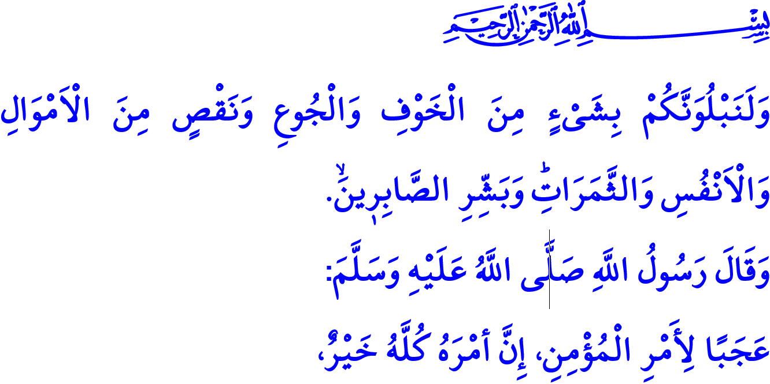 THE ISLAMIC ATTITUDE TOWARDS CALAMITIES
Honorable Muslims!
One day the Prophet Muhammad (saw) saw a woman crying out loud by the grave of her deceased child. “Fear Allah and be patient!”, he advised to the sorrowful mother. "Mind your own business! What has troubled me has not troubled you!", said the woman, failing to recognize him because of her pain. A while later when she realized that it was the Prophet Muhammad (saw) who advised her to do so, she went near him and expressed her apologies. Then came the following striking advice from him,  “True patience is that which comes at the first blow.”
Dear Believers!
It is inevitable that all of us have troubles, pains, sorrows, and material and spiritual problems in life. This is the reason why this world is called "the world of trials". In this respect, the Prophet Muhammad (saw) endured the worst of such trials that we strive to come through in our own lives. He lost his father before he was even born, and his mother when he was only six years old, and had to grow up without a father and mother. Moreover, he suffered the loss of his beloved wife and his six children. He, together with a handful of believers, had to endure the polytheists’ merciless pressures, tortures, restrictions, and exclusionary behaviors. Despite all these troubles and problems, he never lost his faith and hopes, always sought refuge in Allah, and asked only Him for help. He embraced mercy other than violence, and never resorted to solutions that Allah would disapprove.
Dear Muslims!
In the verse I have recited at the beginning of the khutbah, the Almighty Allah (swt) states, “We will surely test you with something of fear and hunger and a loss of wealth and lives and fruits, but give good tidings to the patient!”
None of us naturally would like to encounter hardships. But as Muslims we all know that while there are good times in life, we also have bad times as a part of our trial in this world. Allah the Almighty (swt) tests us through depriving us of our possessions at times, and through giving us plenty of blessings at other times. It is therefore important for us not to lose control and go rebellious in the face of problems, but rather be patient and remain composed. We act in line with the common sense and reason.
We fulfill our responsibilities to overcome the problems. We seek wisdom in and draw lessons from all troubles for our life in this world and for the one in the Hereafter. We self-question ourselves regarding our mistakes and failures in order not to experience similar problems again. We consult the knowledgable and experienced people, and then rely on Allah (swt) for the consequences.
Dear Believers!
In one occasion the Prophet Muhammad (saw) said, “How wonderful is the case of a believer; there is good for him in everything and this applies only to a believer. If prosperity attends him, he expresses gratitude to Allah and that is good for him; and if adversity befalls him, he endures it patiently and that is better for him.”
Holding on to life both in good times and in bad times and taking strength from our connection to Allah, then, is a sign of the beauty of the faith we have. It is cruel for people to turn their despair into violence and vent their anger on women and children in overwhelming situations. Any problem, disagreement, or overwhelming situation cannot be an excuse for violence against women. For that matter, violence means to infringe upon the rights of people and to poison family members by sowing seeds of pain and hatred. Muslims, however, should remain to be such people from whose hand and tongue can come mercy only and who instill peace and trust in their environment. It is never a solution to harm oneself and family members in the face of problems. Islam does not approve hurting the lives of people or taking one's own life that is entrusted by Allah, even to cease the pain. This is because if there is a problem, so is Allah as the Solver of problems. “Allah is the best Protector and Helper!” If there are troubles, there are also friends, neighbors, and relatives to find solutions to them. “The believers are but brothers!”
Dear Muslims!
Let us not turn our pains into rebellion and oppression. Let us not forget that our patient and strong stance against our problems indicates that there will be much easiness for us before Allah (swt). We are here in this world to have faith and do good deeds. Let us remember the Prophet Muhammad's (saw) hope-increasing and comforting words, “All troubles, even if it is the pricking of a thorn, that befall a Muslim serve for his/her sins to be forgiven.” Let us not give up our hopes that Allah shall help us and be merciful to us. Let us pray to Allah (swt) in the words of the Prophet Muhammad (saw), “We belong to Allah and to Him we shall return. O Allah! Compensate me in my affliction, recompense my loss and give me something better in exchange for it.”

Bukhari, Jana’iz, 31.
Baqarah, 2/155.
Muslim, Zuhd, 64.
Anfal, 8/40.
Hujurat, 49/10.
Bukhari, Marda, 1.
Muslim, Jana’iz, 4. General Directorate of Religious Services

